UNIT 8: PRESENT CONTINUOUS – POSITIVE

EXAMPLES

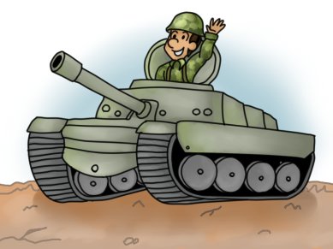 | 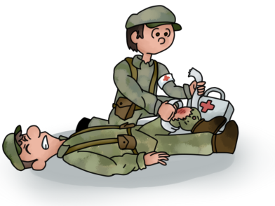 | 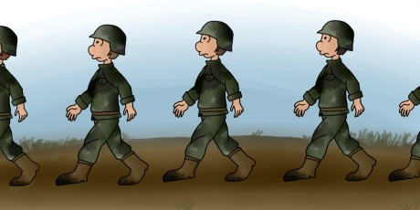
I am standing in a tank. | He is treating the injured. | Soldiers are marching.

FORM

SINGULAR |  | PLURAL
FULL FORM | SHORT FORM | FULL FORM | SHORT FORM
I am working  you are working  he / she / it is working | I'm working  you're working  he's / she’s / it’s working | we are working  you are working  they are working | we're working  you're working  they're working

AM / IS / ARE + V-ing
SPELLING CHANGES
no changes (add only -ing) | remove -e before adding -ing | double the last consonant before adding –ing
approach → approaching  bomb → bombing  climb → climbing | decode → decoding  charge → charging  locate → locating | drop → dropping  set → setting  ship → shipping
Be careful! | die → dying; lie → lying

USE

We use the present continuous to talk about:
- things that are happening now, at this moment
They're preparing the equipment for the exericise.
- temporary activities
We're working with the German contigent this week.
- ongoing changes or trends
The number of recruits is reducing.
- future arrangements
I'm meeting the commander in an hour.
22
We do not use stative verbs with the present continuous.
- verbs expressing feelings, mental or emotional states: dislike, envy, fear, forget, hate, love, like, prefer, want, wish
- verbs expressing senses: appear, feel, hear, see, seem, smell, sound, taste
- verbs expressing thinking: believe, imagine, know, mean, realize, recognise, remember, understand
- communication verbs: agree, deny, disagree, mean, promise, satisfy, surprise
- abstract verbs: be, care, contain, cost, depend, exist, need, owe
- possession verbs: own, belong, possess

MORE EXAMPLES

- Listen! The soldiers are coming back to the base.
- Please be quiet! I'm trying to finish this report.
- Look at Sam! He's fixing that truck again.
- The instructors are working with recruits at the moment.
- My unit is doing a shooting exercise now.
- Our battalion is in Haiti. They are serving there as part of the UN mission.

EXERCISES

A Write -ing forms for the verbs.

- defend __defending___  - exercise ____________  - dig __________ | - supply __________  - climb __________  - fire _____________ | - get __________  - leave __________  - lie __________

B Write the correct form of the verb.

- The commander ____is holding___ a meeting. (hold)
- The enemy _______________ towards the village. (move)
- The plane _______________ off. (take)
- The UN forces _______________ the area. (monitor)
- The soldiers _______________ to their commander. (listen)
- My unit _______________ the north field. (control)
- The MP officer _______________ the incident. (investigate)
- Mayday, mayday! The ship _______________ ! (sink)
23
C Match two expressions with each picture.

point to the map clean the machine gun lie on the ground salute the officer
hold briefing hold a sniper rifle stop the vehicle walk in front of soldiers
shout and count kneel stand at the check point do sit ups

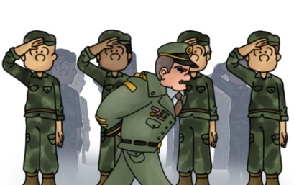 | 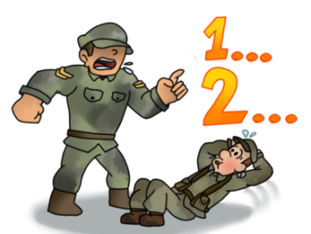 | 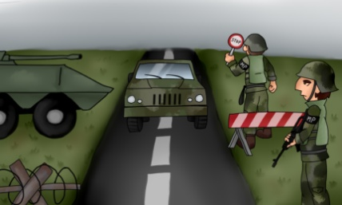
1. ____salute the officer____  2. _walk in front of soldiers_ | 3. ______________________  4. ______________________ | 5. ______________________  6. ______________________
 | 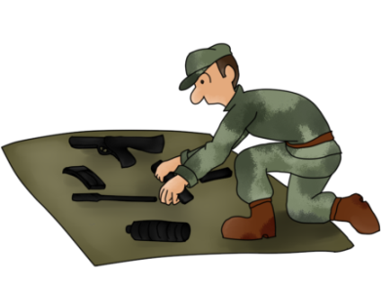 | 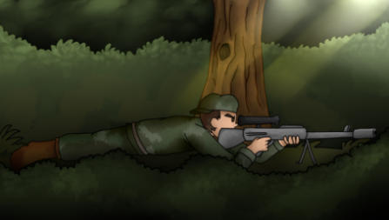
7. ______________________  8. ______________________ | 9. ______________________  10. _____________________ | 11. _____________________  12. _____________________

D Write two sentences for each picture in Task A.

- ____Soldiers are saluting the officer. The officer is walking in front of the soldiers.____
- ________________________________________________________________________
- ________________________________________________________________________
- ________________________________________________________________________
- ________________________________________________________________________
- ________________________________________________________________________
- ________________________________________________________________________
- ________________________________________________________________________
- ________________________________________________________________________
- ________________________________________________________________________
- ________________________________________________________________________
- ________________________________________________________________________

24
E Describe the pictures. What are the soldiers doing? The verbs in the box will help.

poke shoot observe lie walk monitor stand kneel
wait jump hold watch aim fire carry search wait

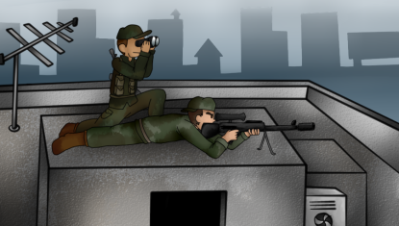 | 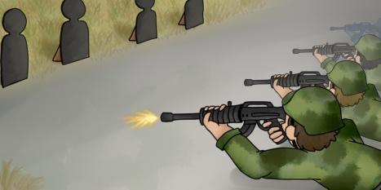 | 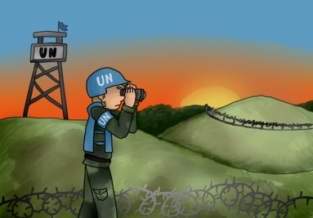
__The shooter is aiming.___  __One soldier is kneeling.__  __The other soldier is lying._ | ________________________  ________________________  ________________________ | ________________________  ________________________  ________________________
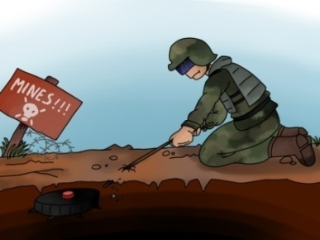 | 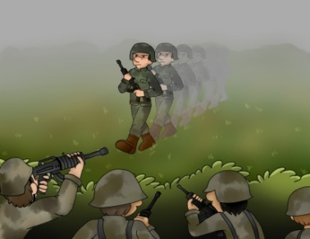 | 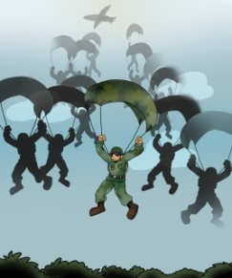
________________________  ________________________  ________________________ | ________________________  ________________________  ________________________ | ________________________  ________________________  ________________________

F Write about people you know. What are they doing at the moment?

- my best friend __He is driving to work at the moment.___________________
- soldiers from my unit __Soldiers from my unit are standing on the parade ground.__
- __________________ ____________________________________________________
- __________________ ____________________________________________________
- __________________ ____________________________________________________
25

G And what are you doing at the moment? Write three sentences.

- __I’m learning about Present Continuous._____________________________________
- ________________________________________________________________________
- ________________________________________________________________________
- ________________________________________________________________________

