Opening Remarks – Dr R.D. Monaghan, CH BILC

These notes accompany the slide presentation “Opening Slides”.

1

Welcome to the 45th Annual BILC Conference, and welcome to beautiful and historic Vilnius.

I have the honour to address you as Chair of the BILC Secretariat, the executive body of the Steering Committee which represents your interests in NATO for language issues. For those of you new to BILC, our raison d’être is to share knowledge and expertise in language education, training, assessment and management, and to help each other meet our national commitments to the Alliance. This past year, 2010-2011, has been challenging for all of us, given the consequences of global financial pressures, a persistently high operational tempo, arising threats in neighbouring countries and urgent joint operations, as well as the ongoing transformation of NATO itself. Operational requirements have exerted considerable pressure on language education, training, and assessment, so the theme of this Conference, “Developing Operational Proficiency,” is not only appropriate but timely. Our agenda, including both presentations and study groups, looks at what these pressures are, how we are addressing them, and how we see ourselves meeting current and future demands on our diminishing resources. This promises to be a very rewarding Conference indeed, and I urge you to share with all of your colleagues at home what we resolve to do, and how we resolve to do it, when you return to your homes next week. It is of little use to harbour knowledge privately; this is something all educators know. What each of us has to say here is of value to more than those who agree with us. Your thoughts will ripple through a large network of language and Human Resource professionals around the globe. So share, discuss, and debate. Practical learning does not occur in isolation.

Why do we share what we learn? If a problem is resolved and its resolution is not documented or communicated, the same problem is identified and resolved repeatedly, resulting in a waste of energy and resources. As a primary goal of BILC is to share knowledge and expertise, I urge you to take the debate back to your own establishments so that you can share the wealth.
2
There are two things I’d like to do today: outline new guidance and reporting structures for BILC, and comment briefly on assessment of higher level proficiency.

3

Guidance and Reporting

Some of you are aware that BILC has reported to the Joint Services Sub-Group (JJSG) since 1978, a little after a decade of BILC’s constitution. Until this past March, JSSG was one of the Sub-Groups that received direction from and reported to the NATO Training Group (NTG), which in turn took direction from Allied Command Transformation (ACT), one of the two constituents of the International Military Committee. A wiring diagram better explains the structure:

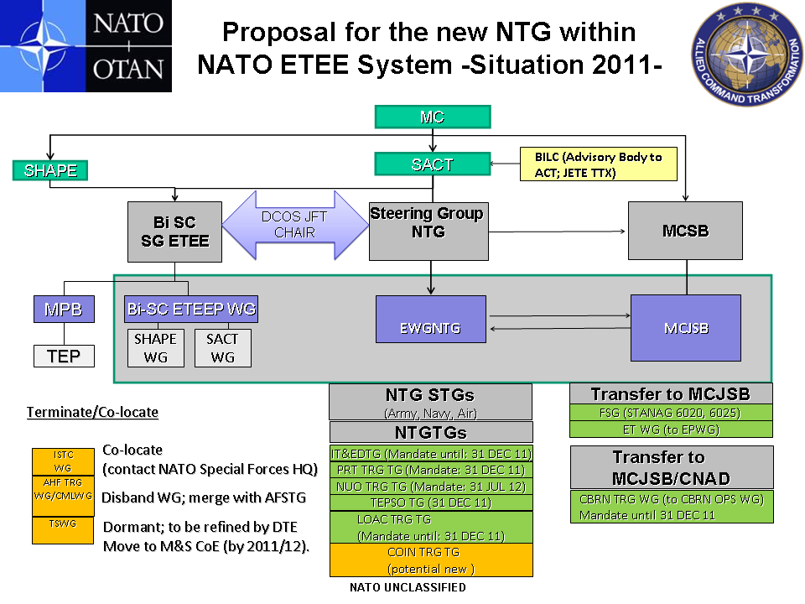

The reorganization of NTG to make it more flexible, adaptable and efficient has consolidated the Army, Navy and Air Force Sub-Groups with JSSG to become the Executive Working Group of NTG. The Finance Sub-Group moved laterally to the Military Committee Joint Standards Board, and dormant groups were terminated or co-located. There is no provision for Advisory Bodies, which BILC is, within this new structure, which is tactical and operational.

The key change for us at BILC is that we have been re-assigned to Joint Force Trainer (JFT) within Supreme Allied Command HQ. Our role as subject matter experts in language issues is recognized as strategic rather than tactical, but to maintain awareness of what other working groups and task groups within NTG are doing, BILC will deliver a report to the NTG Steering Group in the autumn of each year.
4
Our program of work, recommended and endorsed by the BILC Steering Committee at our annual Conference, will be approved by JFT and we will receive guidance from JFT directly. The time lapse between recommendations and approvals, and between requests for BILC’s aid and acknowledgement of requests, is greatly reduced and will doubtless accelerate our business cycle.

To illustrate how quickly BILC will be able to act within this new structure, the recommendations of the study group dedicated to strategic guidance can be presented to the Steering Committee and relayed to JFT by the end of May to be incorporated in our new terms of reference. In the past, such a set of recommendations would have to be first approved by JSSG, then approved and sent up to NTG before being seen by JFT – this could take anywhere from twelve to eighteen months, given that no clarifications were required.

I hope to be able to report to you on BILC’s recommended new Terms of Reference and proposed Program of Work on Thursday.

5
ASSESSMENT OF HIGHER LEVEL READING AND WRITING

The second topic I wish to address is the assessment of high level reading and writing skills.

Those who attended the Istanbul meeting are aware that there is growing concern about testing at the higher levels, particularly STANAG 6001 ed. 4 Level 4 in all four skills. A study group will address this issue over the course of the conference. The recommendations of this group, if approved by the Steering Committee, could be presented to JFT by the end of May as well.

I have some experience in assessing higher level Language performance and proficiency. Some of you know that I taught some thirty years at college and university before joining the Defence Team in Canada. In my long career as a hands-on educator, daily practice was to elicit reactions and debate to assigned tasks and discussion, to instruct students in the formal use of language to convey thought, responses, and reactions, and to assess the quality of those reactions and responses for both formative and summative purposes. I became pretty good at my job. In 1995, I was seconded to the Ministry of Education in Quebec to develop an assessment protocol to determine if students graduating from colleges were proficient in their language of instruction. The results of the assessment, with other criteria, would determine whether students could be admitted to university in Quebec. By the time I returned to my college two years later, the Ministry was conducting assessments of reading and writing in three sittings for 50,000 students a year. The same throughput is maintained today. Students are required to respond critically to the content and intent of a selection of one of three texts (essay or short stories) over the course of four hours in at least 750 words. Students on the English side (20%) are graded on Comprehension and Insight, Organization of Response, and Expression. Assessors, for the most part college and university teachers, are hired and trained for three large-scale double-blind marking sessions conducted (and moderated by a third or fourth reader as required), each year, and results are posted quickly (usually within a few weeks). Students may request rereads but rarely do.

Organization of Response addresses the larger structural patterns – introduction, body, conclusion, detailed support of arguments and observations – and Expression addresses the mechanics of grammar, orthography, citation protocol, and sentence variety and structure. Comprehension and Insight addresses understanding of the readings and the quality of the response.
6
One rubric for Comprehension and Insight is the recognition of rhetorical techniques and devices:
The exam asks students to identify the rhetorical techniques and/or devices used by the author of the selected reading. Simply put, the techniques and devices are the building blocks of the essay or short story. They are the strategies and tools, the rhetorical and literary elements which the author uses to achieve an intended effect on an audience. [Test Instructions]
7
Students are asked to conduct a critical analysis of the writer’s success or failure in achieving his/her intent using by the analytical tools they have been taught over their college career. Within nations we do much the same except that we rely on informal (life experience and work) rather than formal education.

Here are some of the tools.
8
STANAG 9-15
Some examples of rhetorical techniques and devices are:
16 - 19
allusion  analysis  anecdote  character  classification  comparison  contrast  description  diction  example  imagery  irony | metaphor  narration  overstatement (hyperbole)  plot  point of view  satire  setting  simile  slang  symbolism  tone  understatement

The following direction in the test points to a performance criterion: “Do you recognize and can you demonstrate the use of rhetorical features to convey the intent of a discourse?”

One rubric under Organization is coherence, the use of technique to bind notions together in the mind of the reader. At this point we slide over into the realm of proficiency: structured coherence in writing is not learned through training but developed through application. Techniques to bind notions are simple to enumerate:

Transitions Repetition
Parallelism Pro-forms
Paraphrase Allusion

There are more, but this is a start.

Control over modes is assumed. Argumentation, description, persuasion, narration, comparison/contrast, and process analysis are common rhetorical modes which we meet in the STANAG 6001 descriptors as well as in most college and university rhetorics.

Combine these features (modes, techniques, and devices) as assessment criteria and you can measure the ability of a writer’s response to any given reading.

But this list is a little like a partial recipe – you need to know how to combine the elements to produce tasteful and effective prose. Briefing notes and policy statements are complex documents, as demanding on a writer’s skill as a comprehensible academic paper.

So how does one apply these criteria?
20
Here is an paragraph from an article by Major Michel Boire from the Summer 2006 issue of the Canadian Military Journal:

By 1759, Montcalm commanded a mixed force, bringing together elements from the colonial militia, metropolitan regulars, the independent Franche companies, and Amerindians from many tribes. With such a diversity of culture and interests in its ranks, perhaps a personable commander, one more culturally attuned to the requirement for inspirational frontier leadership, rather than to harsh European discipline, might have been a better commander for such a disparate force. Le Marquis had service in two previous wars, wherein he had witnessed the principal military developments of the 18th Century. Commencing his service at the age of 12, he had been raised in the close-ordered battles of the Old World. In the New World, 35 years later, he would see that an “(a)ggressive, mobile, combative strategy replaced the slow strategy of siege.” As a warrior in the dynastic wars of the 18th Century, Montcalm’s unshakeable belief was that “(t)he army reflected the state. It was divided internally into classes without common spirit, into officers whose incentive was honour, class-consciousness, glory or ambition, and soldiers enlisted for long terms who fought as a business for a living, who were thought incapable of higher sentiments, and whose strongest attachment was usually a kind of naïve pride in their regiments.” Le Marquis’s understanding and conduct of generalship were results of his origins, upbringing and experience. And he was a faithful reflection of them. Montcalm’s strategic decisions, in so much as Vaudreuil permitted them, reflected the finest qualities and most common faults of 18th Century French nobility, who constituted the senior leadership of Louis XV’s army.

How do we assess this using STANAG 6001 descriptors? Is this a 3+ or 4? Perhaps a 4+? Could it be the elusive and unattainable 5? Does such an animal exist? In this text there are no errors, so we have already moved beyond 3 and 3+. Let’s examine the text.

- 16 pronouns in 22 lines, 8 sentences, 260 words.
- Repetition and synonyms/antonyms: 45
- Classification: mixed leads to binary structures, often as lists of contrasting or complementary pairs (7), as triplets (4), or quadruplets (2).
- Sequencing and time references: 7
- These are examples of rhetorical devices. Techniques are more complex and unifying.
- Virtually all of the selection is self-referencing and quite coherent. The French text, in the writer’s other first language, employs the same devices and techniques.

A cursory analysis of elements of coherence in this paragraph yields surprising results. The author uses techniques of narrative and persuasion. There is a temporal reference that is repeated and re-enforced, ample use of repetition and paraphrase, clear transitions (temporal and spatial), parallel structures, the use of clearly referenced pronouns, contrasts of social groupings and attitudes, a balance of sentence lengths and levels of complexity, lists, allusions to persons and types a western reader is familiar with, and a context that Canadians are immediately and sometimes viscerally attached to, as well as the sustained tone of a detached commentator using an elevated register to generate trust. This is highly skilled writing, and yet it appears to be without artifice. A mechanical application of the rhetorical devices and techniques that infuse this 260 words does not produce such fluid results – the ease with which the techniques and devices are used argue for an internalization won through long hours of practice and self-correction. This is not spontaneous writing, but crafted and professional. The French text, incidentally, is as well crafted and demonstrates the same features.

I call your attention to some clever and effective turns of phrase: “Perhaps a personable commander” he writes, telling us that Montcalm was anything but. He refers to “unshakeable belief” and balances “faithful reflection” in one sentence with “reflected” in the next, followed quickly by the superlative balance of “finest qualities and most common faults.” All of a sudden, as a reader and editor, as I recognize this level of sophistication and its effect on me, I sense an aesthetic response to the artistry of the writer. If I were grading it as a graduate student essay, I would scrawl A+ at the top of the sheet and reluctantly move on to more pedestrian stuff. In the context of a STANAG proficiency assessment, I would strongly argue, based on the paper in its entirety, for a 5 in both reading and writing.

But this is only one type of writing, in response to several texts which the author cited above this paragraph. To assess the sustained level of proficiency, I would have to see other types of writing in reaction to other stimuli. Is there the same sort of control in a briefing note, in a prepared speech, in a presentation or a policy draft?

My experience has taught me that the most effective and efficient way to measure higher level reading and writing skills is to combine the tasks and have candidates respond in writing to set readings, within a defined time. I suspect that the most effective way to measure what could initially be characterized as level four responses is to set a series of disparate tasks based on sophisticated texts, and conduct double-blind assessments of the results. And who would be qualified to assess a level four or four plus, and even potentially a level five written response?

I have presented this diversion to simply call your attention to the complexity of assessing higher level writing skills. My own training, my long teaching experience and daily function over decades of assessing spoken and written responses, and my lifelong passion for language stand me in good stead to recognize the difference between mastery of rhetorical forms, rhetorical devices, and rhetorical techniques – and mere control. Control is limited and often obviously contrived. If you are flying in a storm from Vilnius to Frankfurt, would you prefer your pilot to have control or mastery of a pilot’s craft? How does one accurately distinguish between very high levels of proficiency? This reading of one small paragraph demonstrates, I hope, what is involved in determining the differences between threes and fours and fives.

28

29
Finally, I remind you again how important are your contributions, your reservations, your enthusiastic or reserved support of ideas brought forward in the study groups. You are here because your superiors have recognized you as experts in the various aspects of language education and policy and have supported your attendance. Your colleagues are here for the same reason. The informal connections you make at all levels, intellectual, social, or ideological, together with the frank and open debate in your study sessions and in the sidebars, are of immense value to your nations and to NATO.

Take to heart the welcome of our hosts, who have gone to great efforts to provide a milieu that will allow us to collaborate with little stress and great delight on reaching our goals. When you return home, I hope you will all be able to say that you have accomplished much and that you will share those accomplishments with your colleagues.

Ačiu

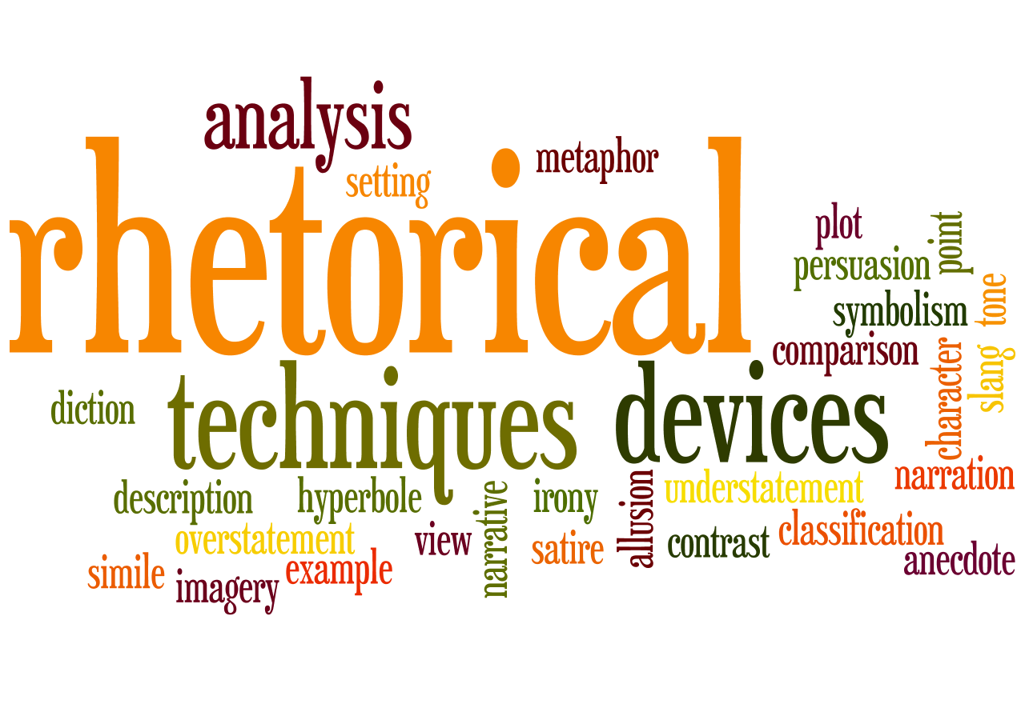

http://www.mels.gouv.qc.ca/ens-sup/ens-coll/eprv_uniforme/anglais/criteria.asp

